.Magnitude & Depth
1. Top 10 strongest earthquakes (mag).
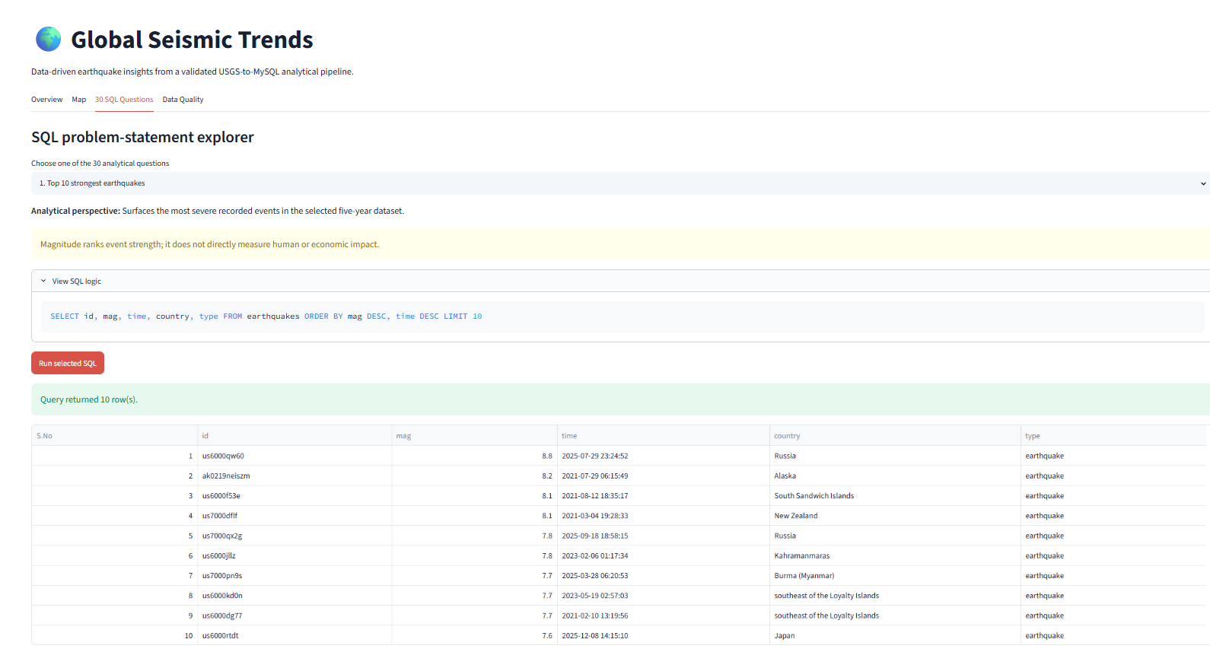
2. Top 10 deepest earthquakes (depth_km).
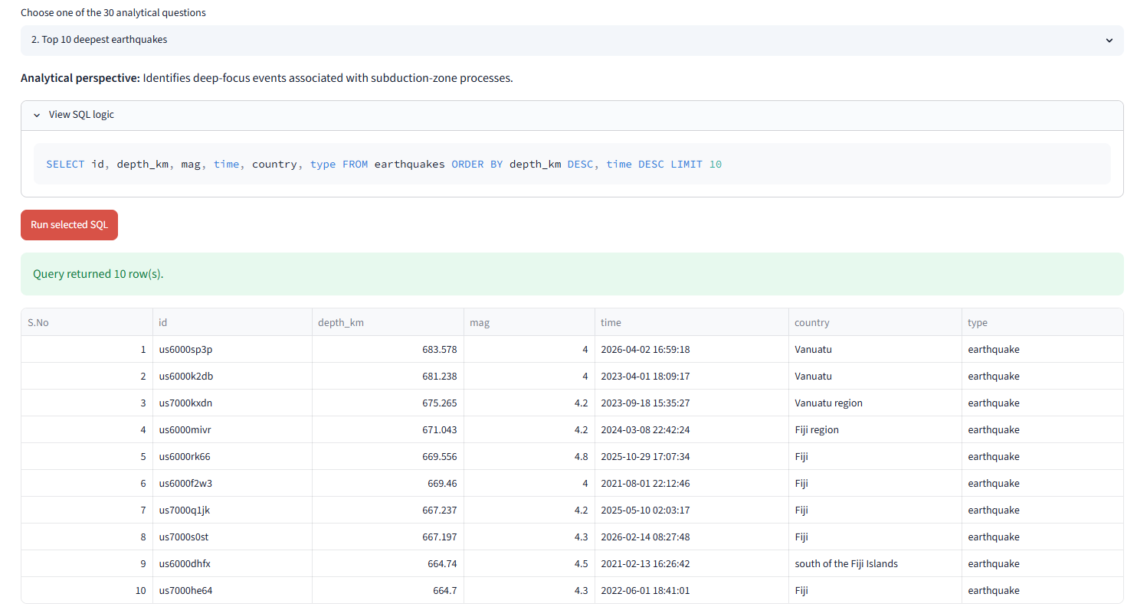

3. Shallow earthquakes < 50 km and mag > 7.5.
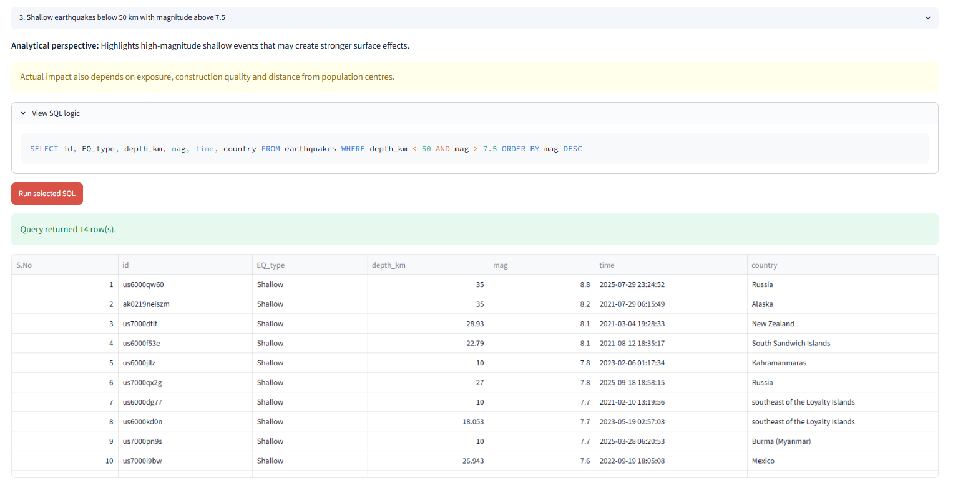
4. Average depth per continent.
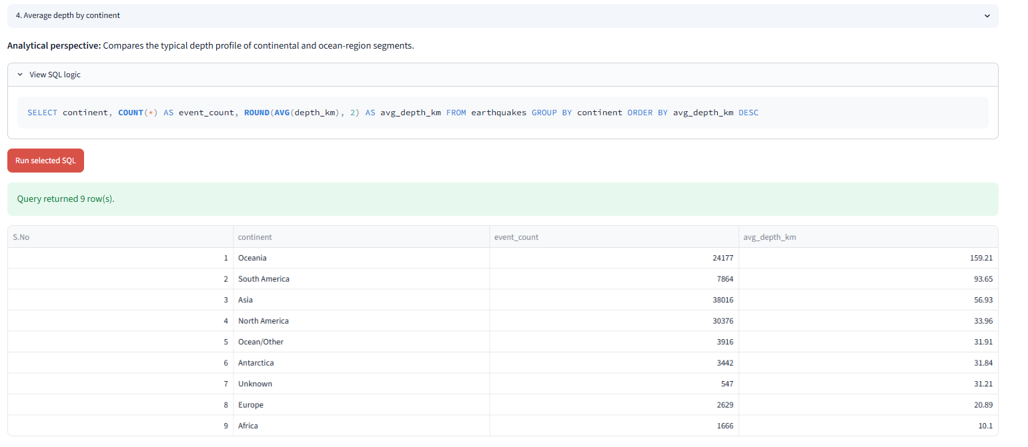

5. Average magnitude per magnitude type (magType).
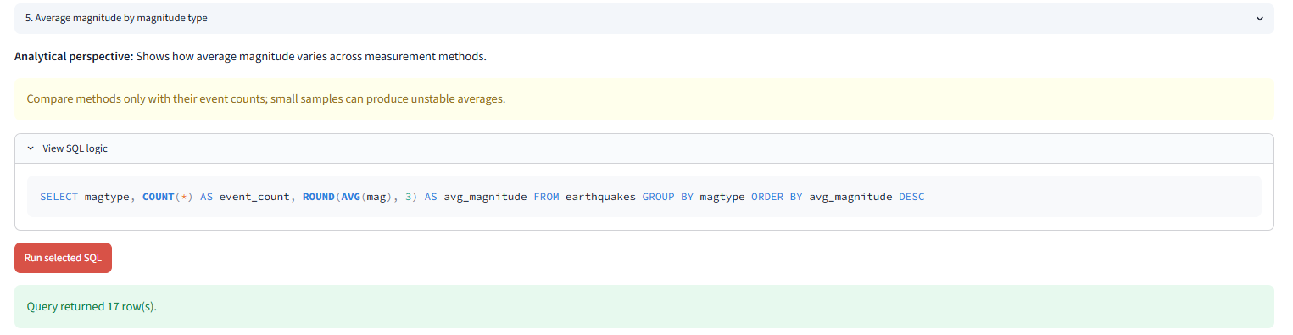
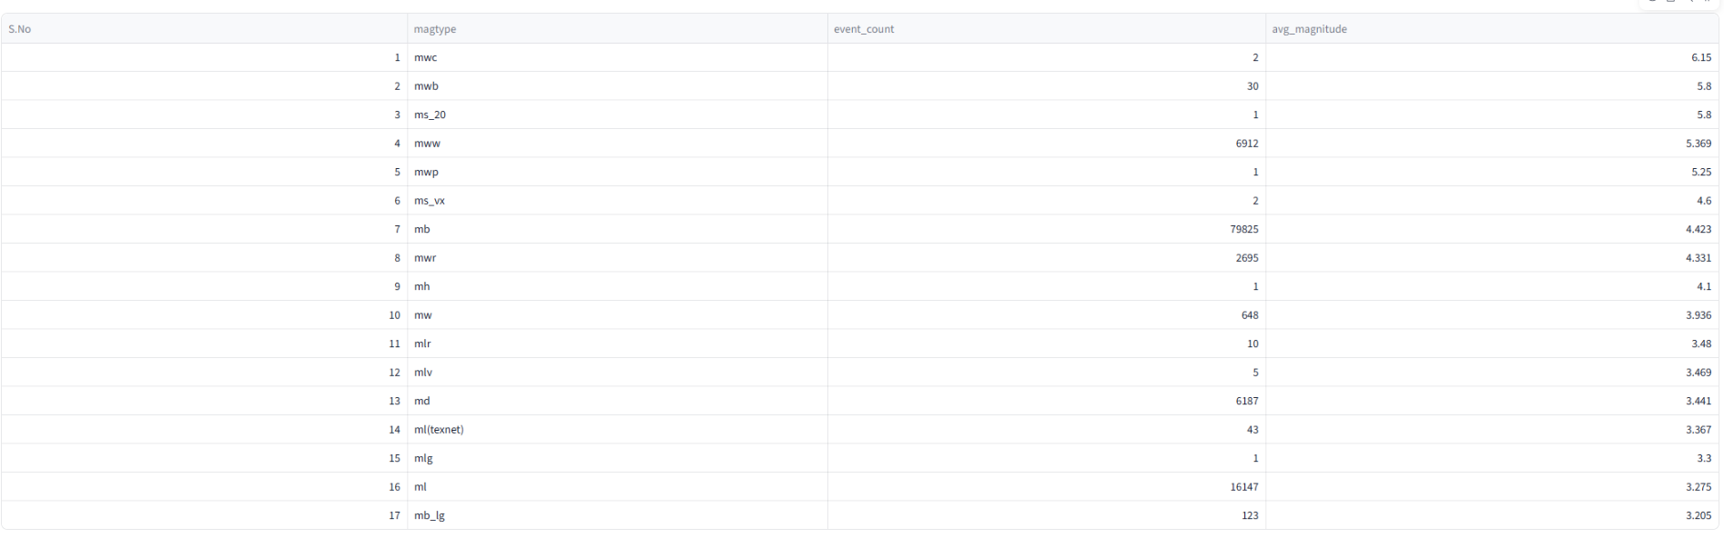

Time Analysis
6. Year with most earthquakes.
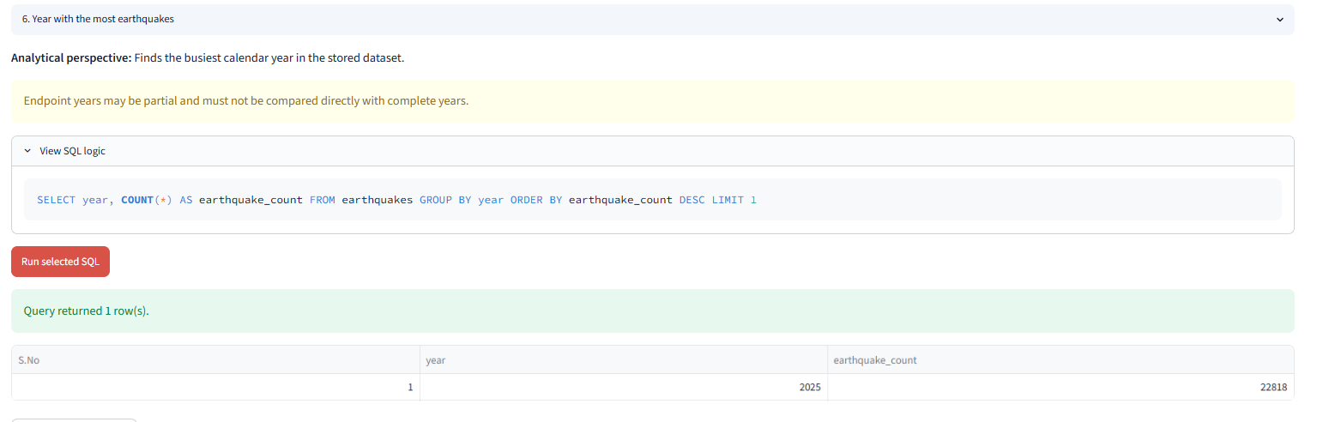
7. Month with highest number of earthquakes.
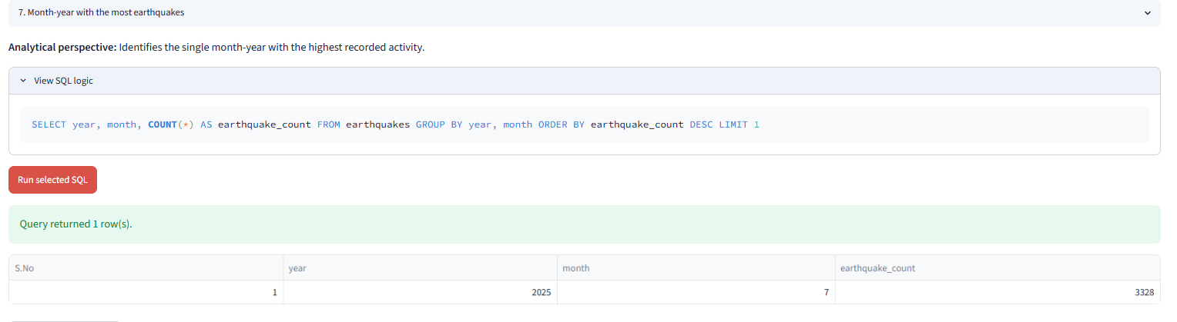
7.1 Month with highest number of earthquakes consolidated in last 5 years.
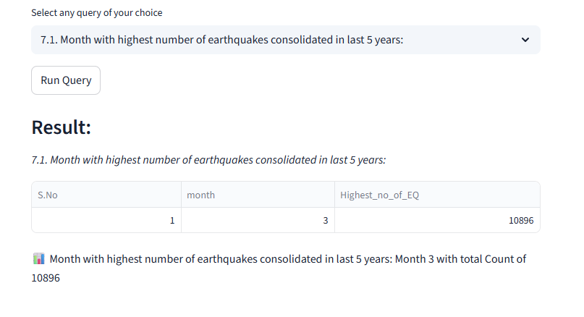
8. Day of week with most earthquakes.
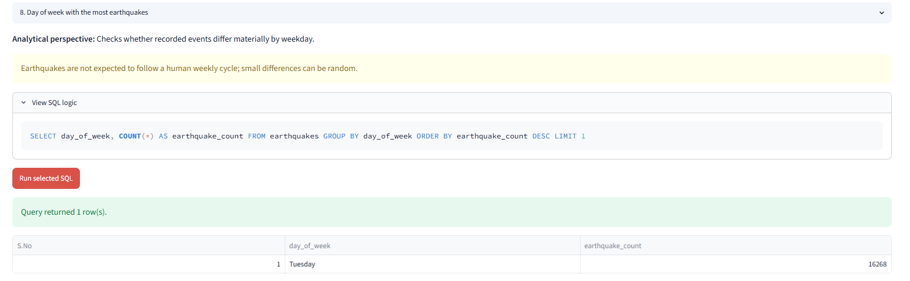
9. Count of earthquakes per hour of day.
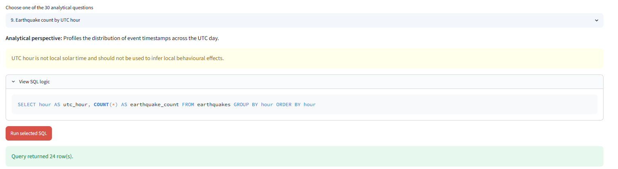
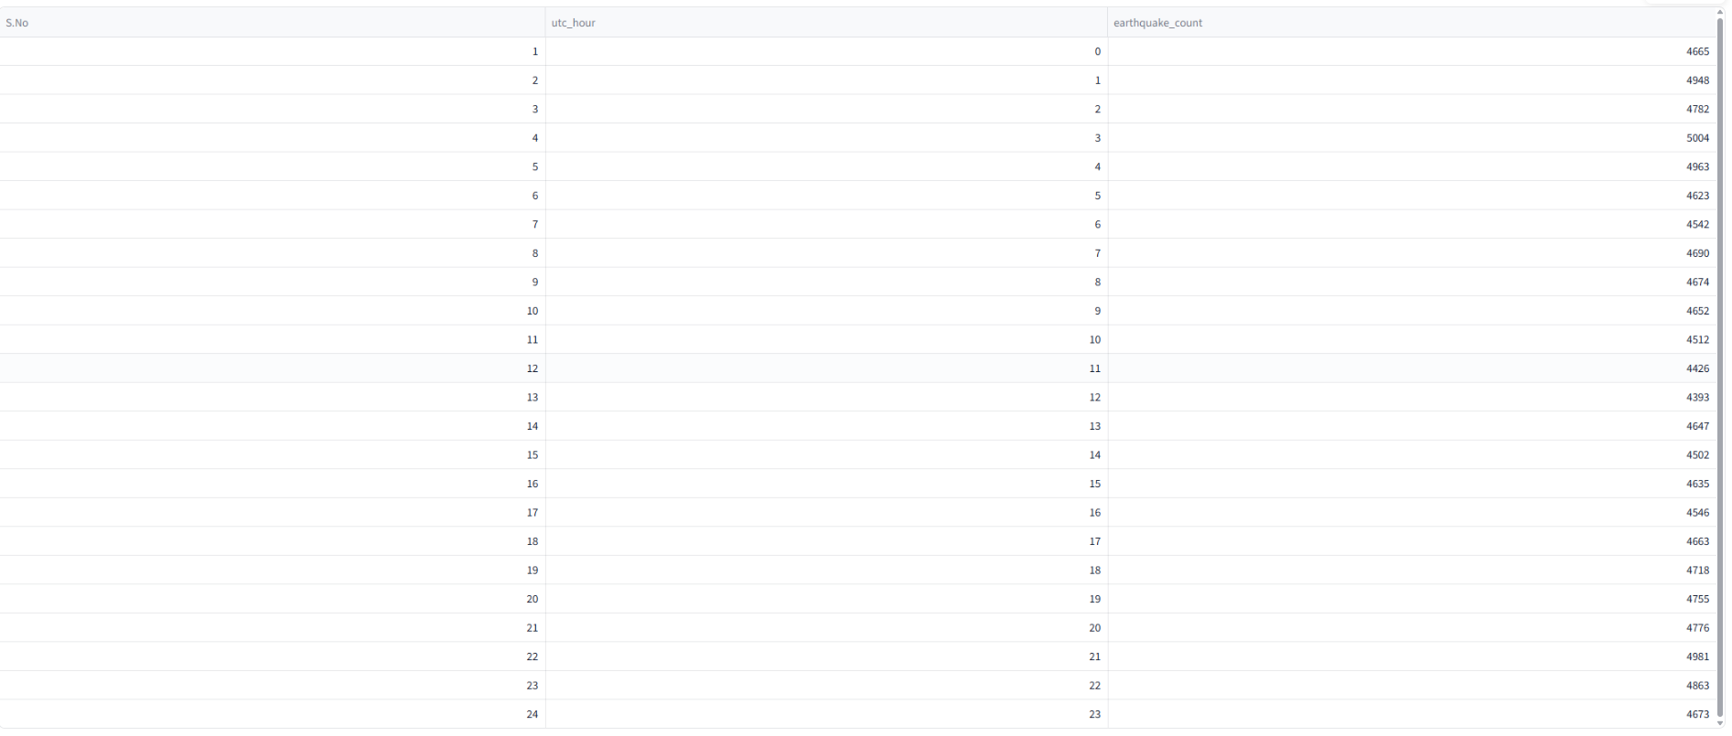
.

10. Most active reporting network (net).
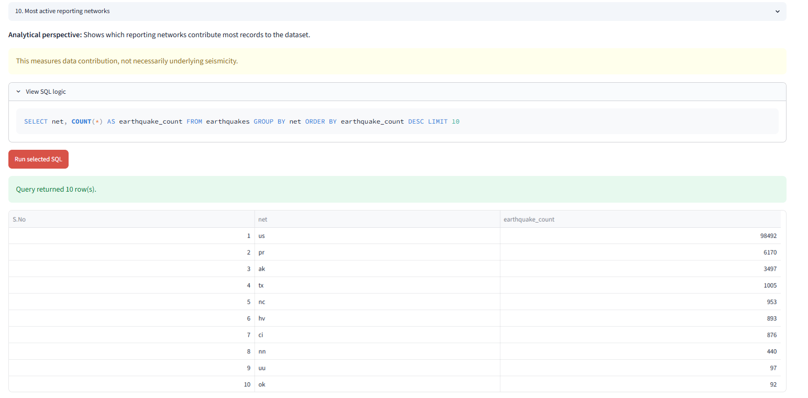

Casualties & Economic Loss
11. Top 5 places with highest casualties.
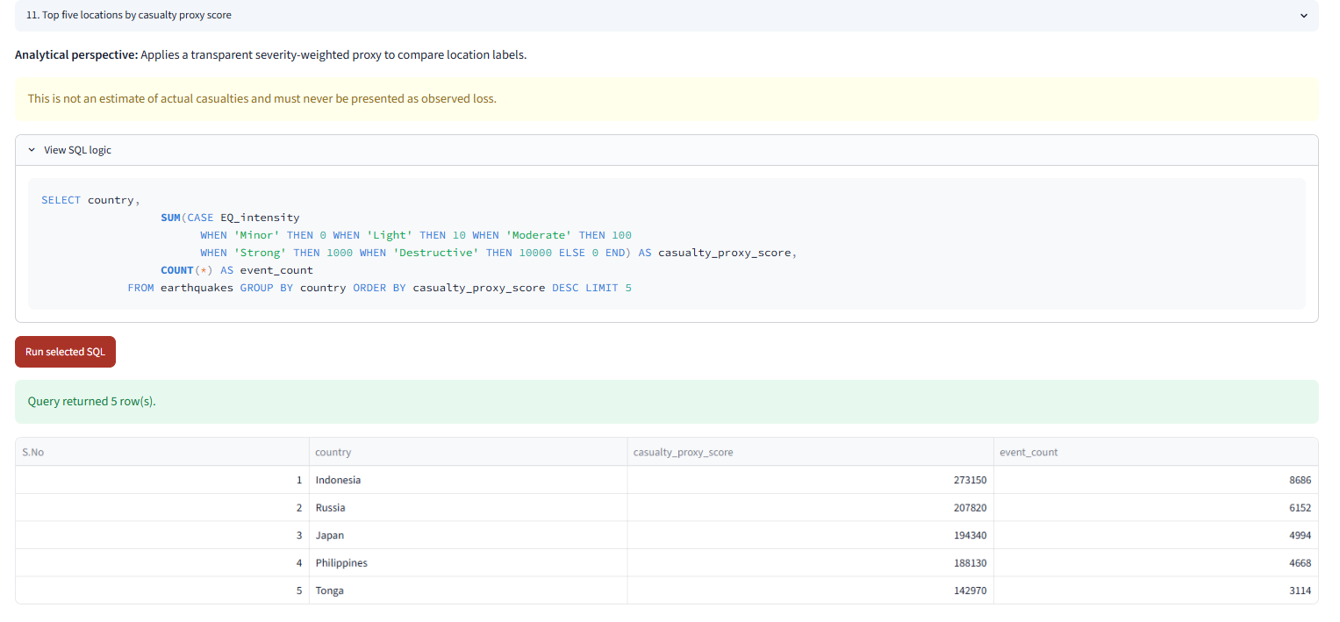

12. Total estimated economic loss per continent.
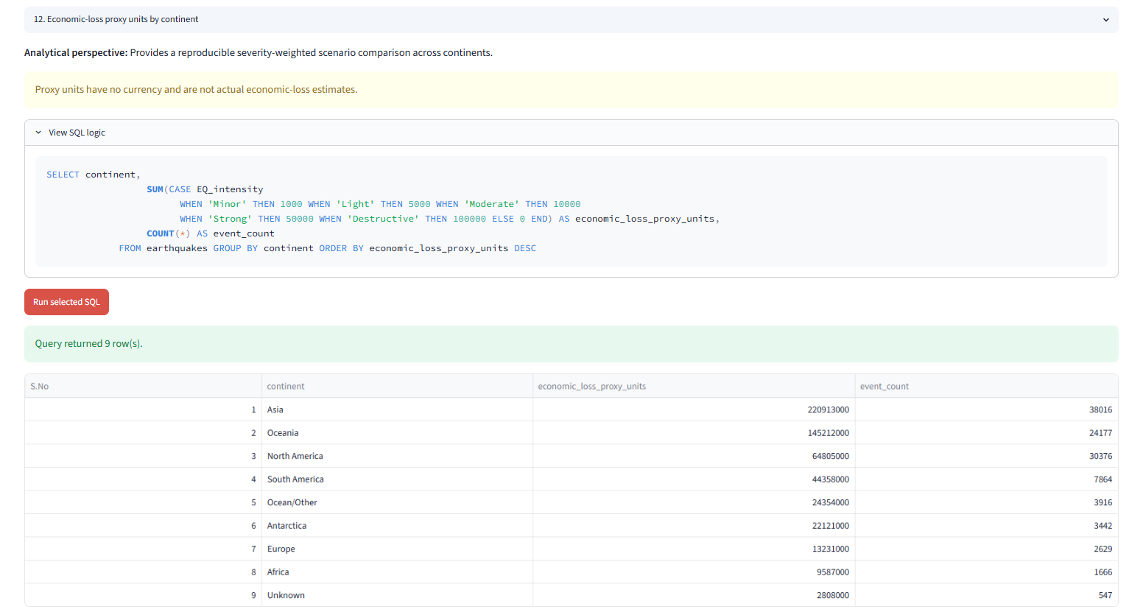
13. Average economic loss by alert level.
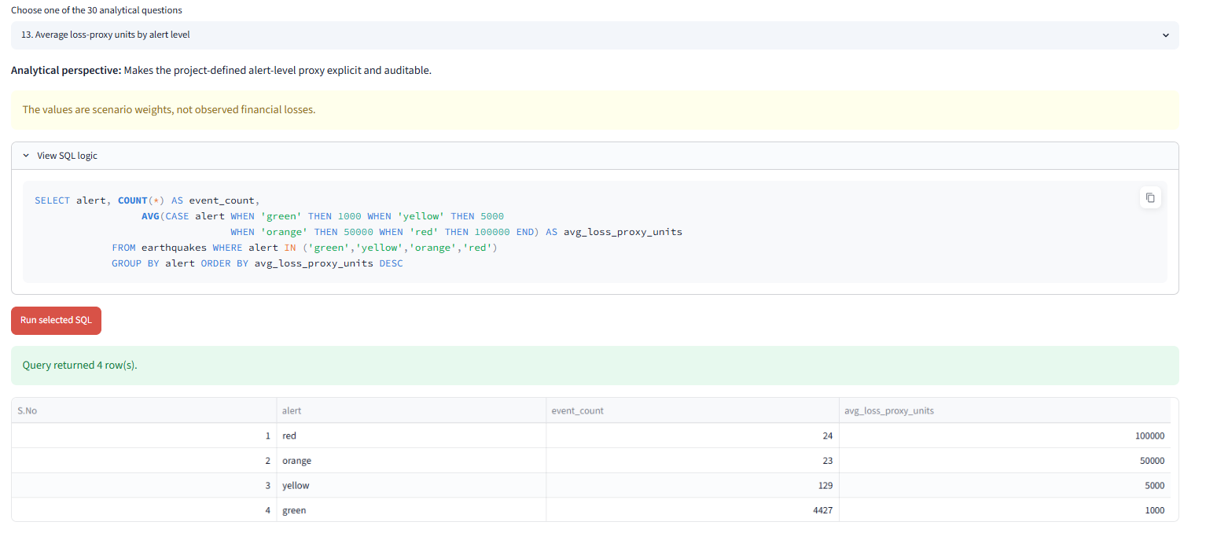

Event Type & Quality Metrics
14. Count of reviewed vs automatic earthquakes (status).
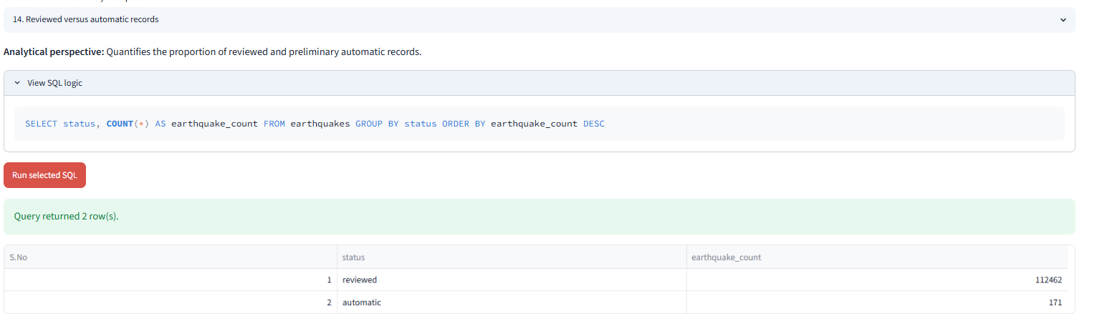
15. Count by earthquake type (type).
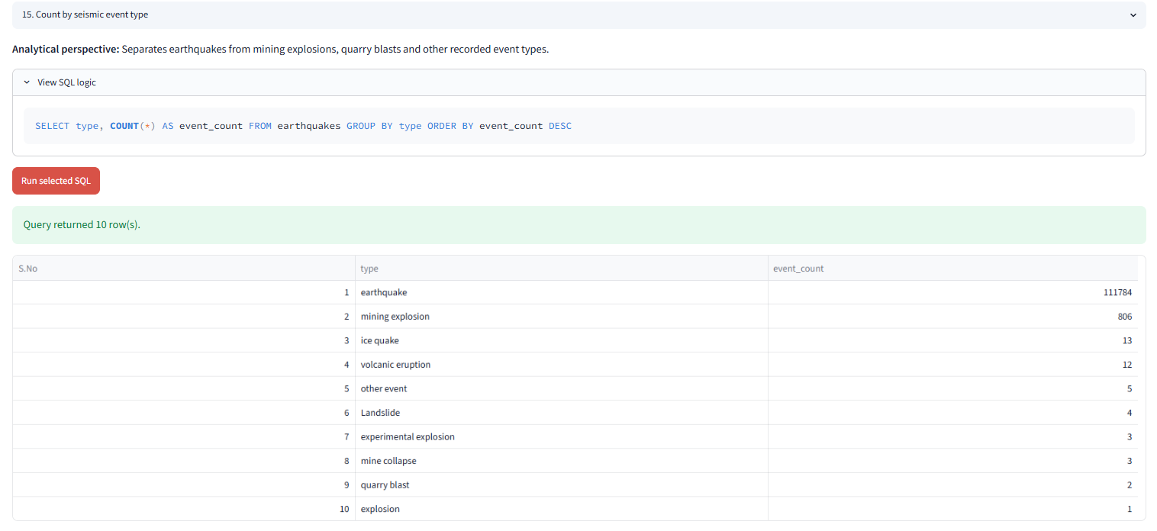
16. Number of earthquakes by data type (types).
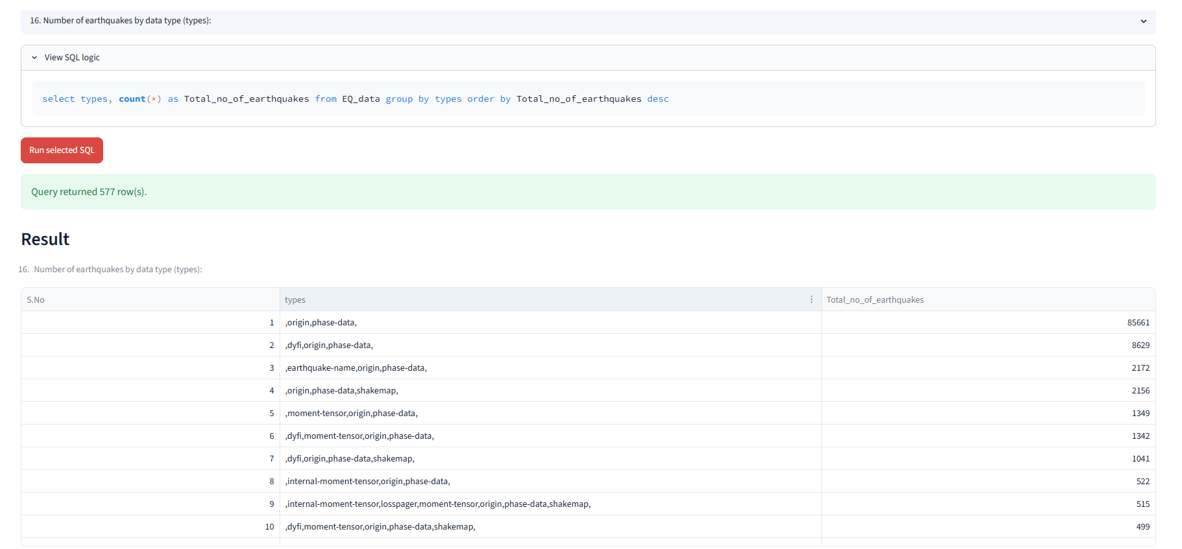
17. Average RMS and gap per continent.
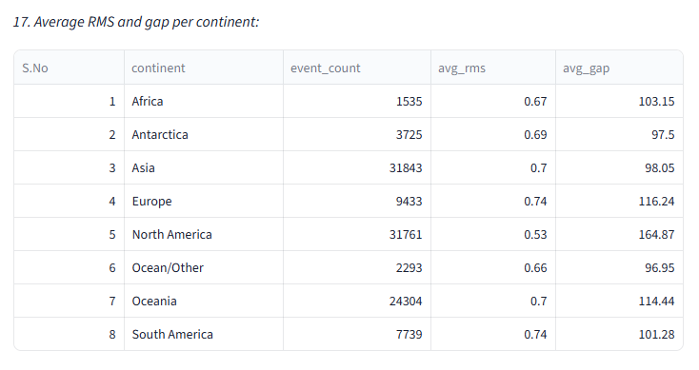
18. Events with high station coverage (nst > threshold).
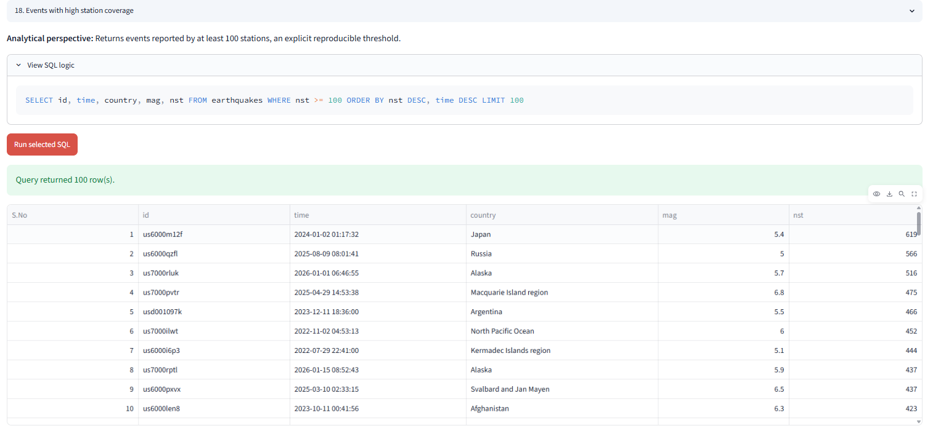

Tsunamis & Alerts
19. Number of tsunamis triggered per year.
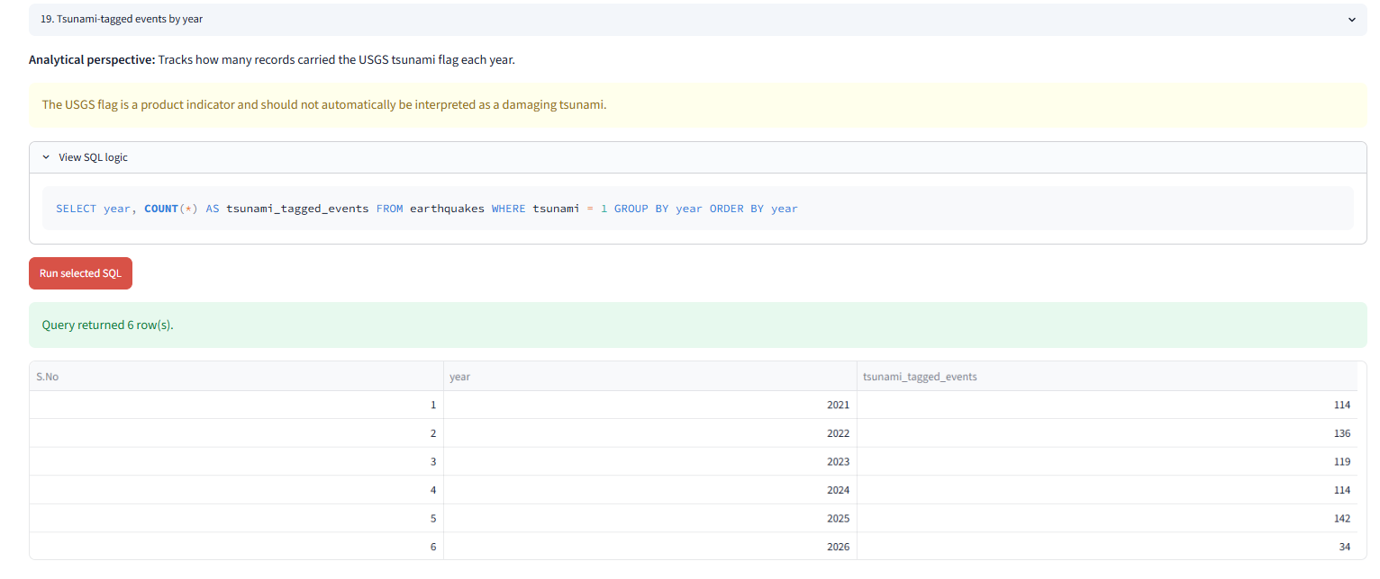

20. Count earthquakes by alert levels (red, orange, etc.).
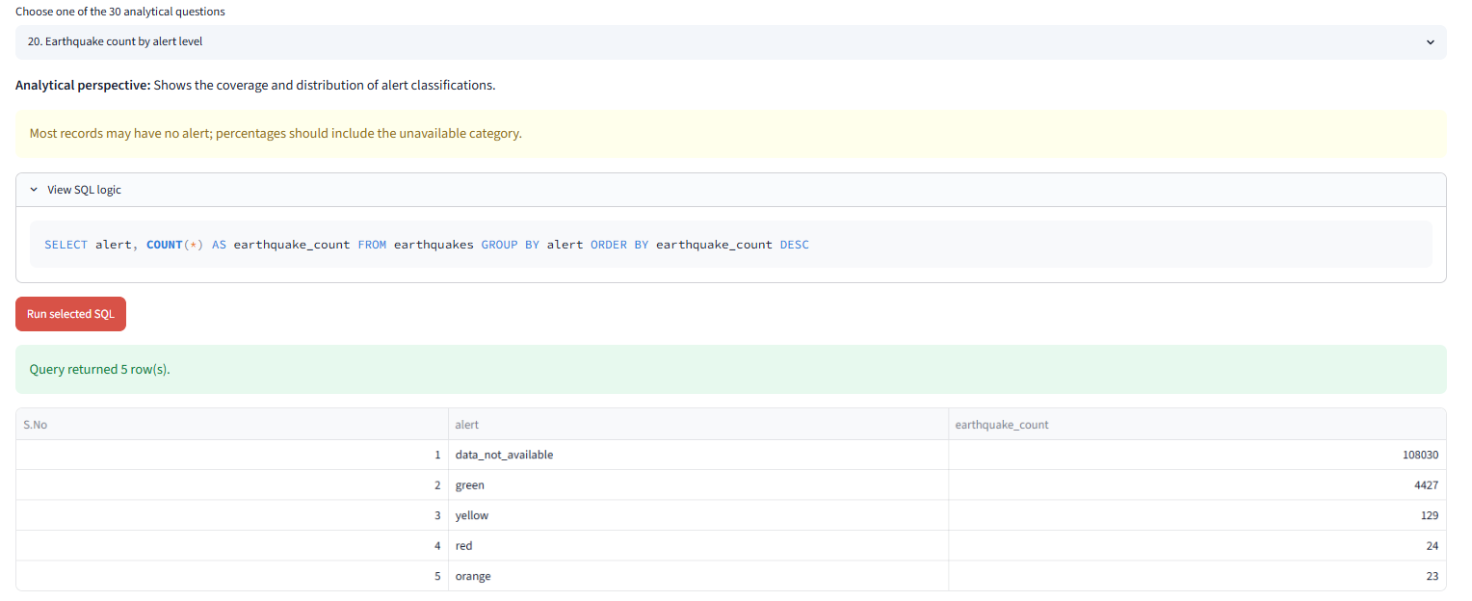

Seismic Pattern & Trends Analysis.
21.Find the top 5 countries with the highest average magnitude of earthquakes in the past 10 years
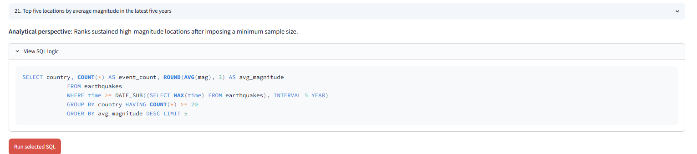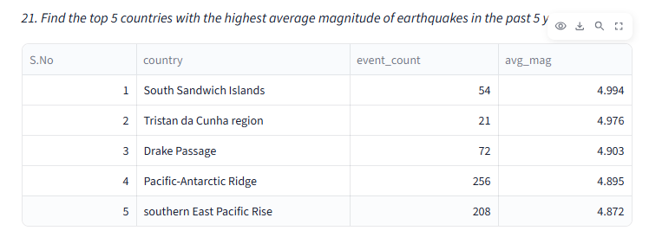

22.Find countries that have experienced both shallow and deep earthquakes within the same month.
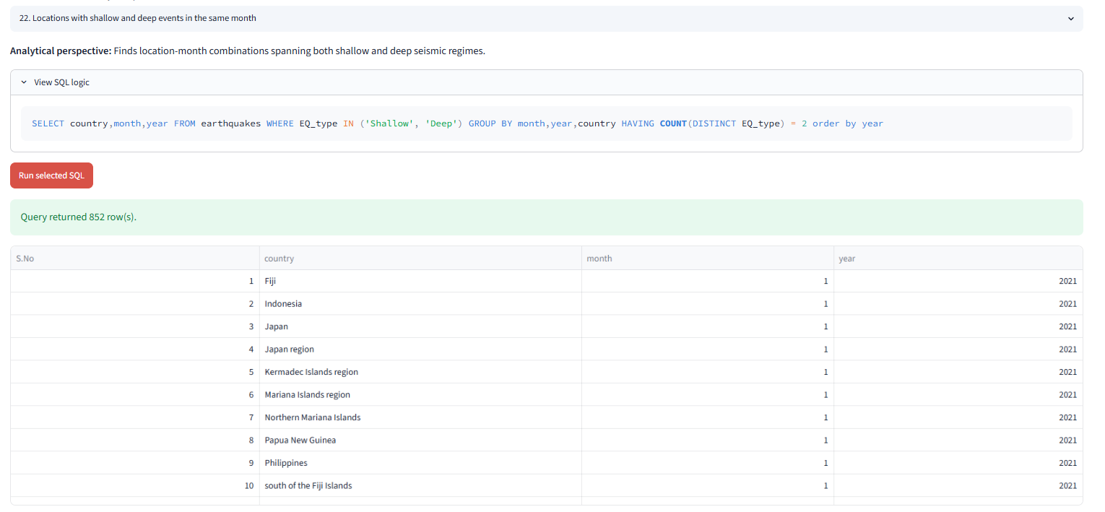
23.Compute the year-over-year growth rate in the total number of earthquakes globally.
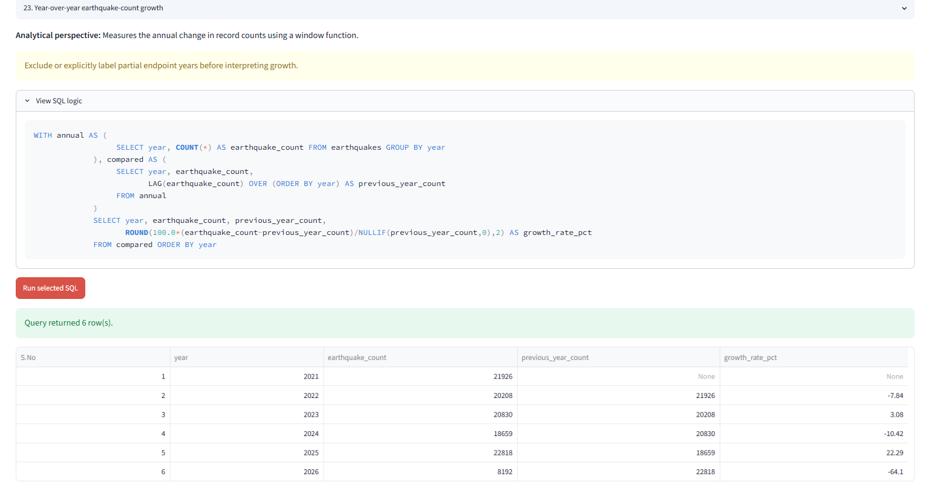

24. List the 3 most seismically active regions by combining both frequency and average magnitude.
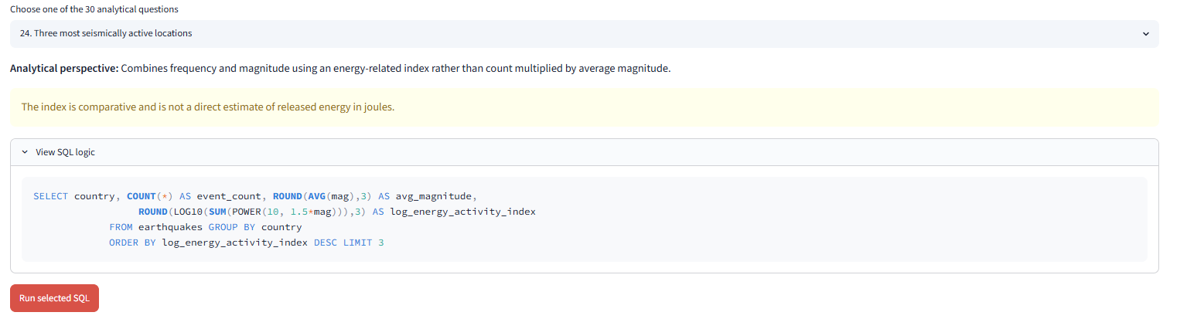
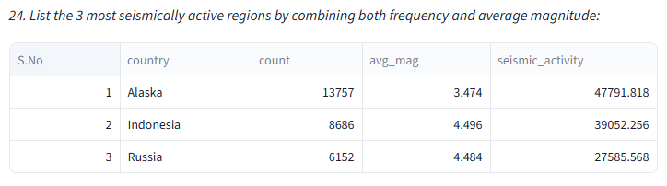
Depth, Location & Distance-Based Analysis.
25. For each country, calculate the average depth of earthquakes within ±5° latitude range of the equator.
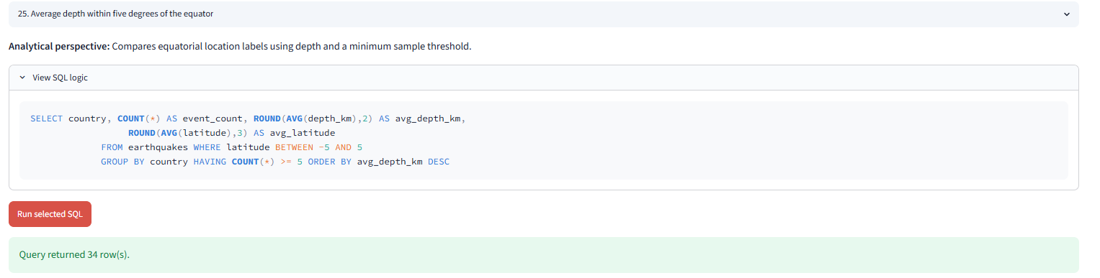
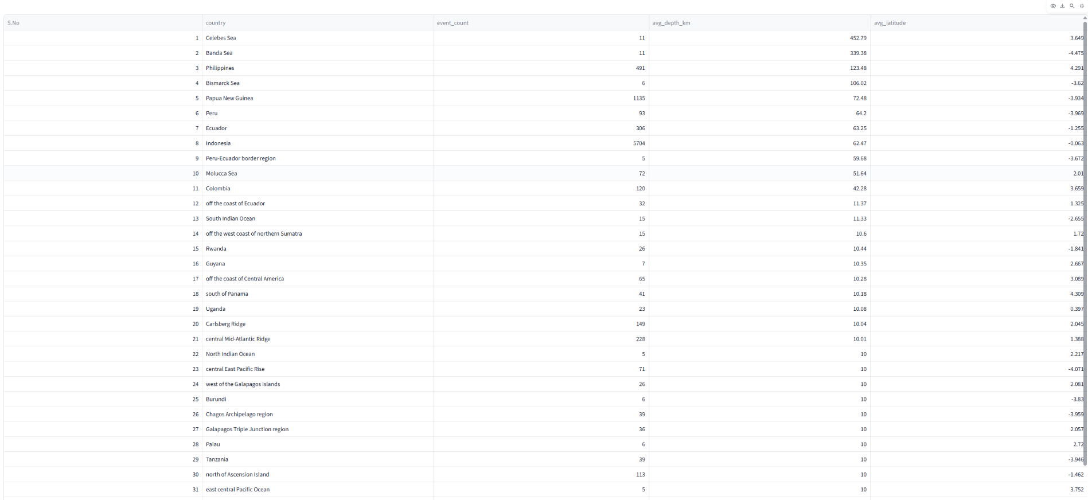

26. Identify countries having the highest ratio of shallow to deep earthquakes.
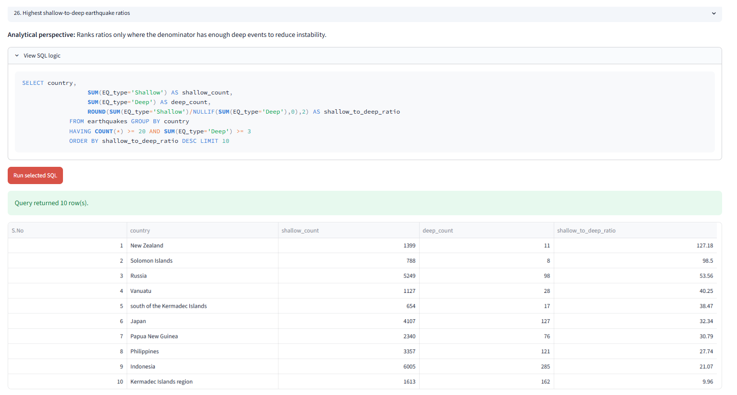
27. Find the average magnitude difference between earthquakes with tsunami alerts and those without.
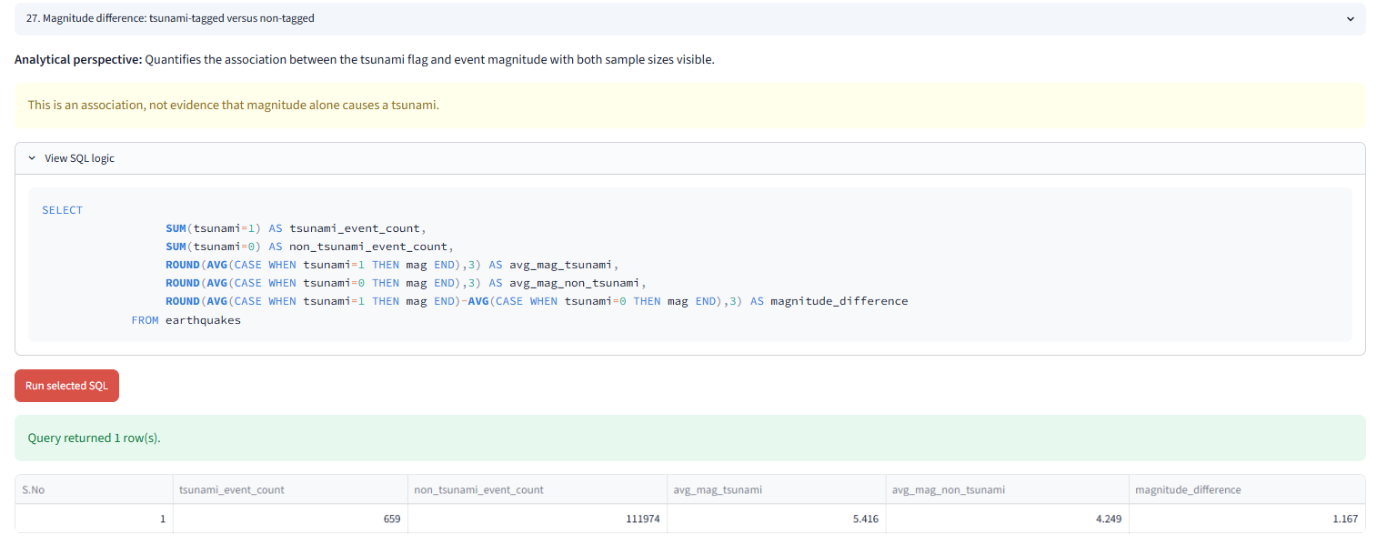

28. Using the gap and rms columns, identify events with the lowest data reliability (highest average error margins).
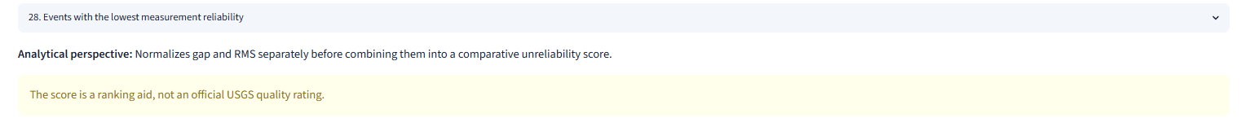
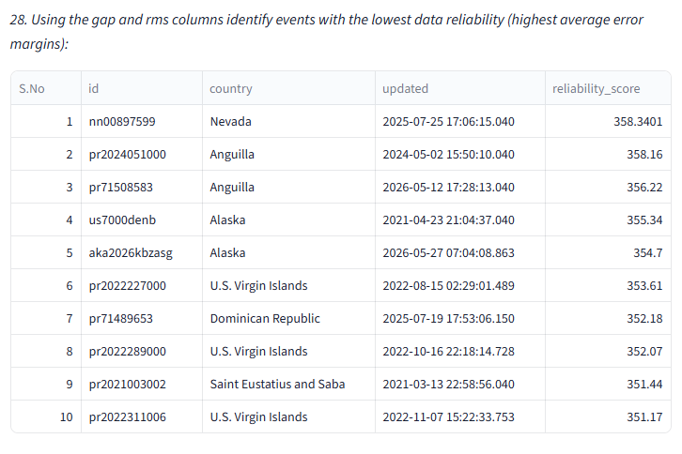
29. Find pairs of consecutive earthquakes (by time) that occurred within 50 km of each other and within 1 hour.
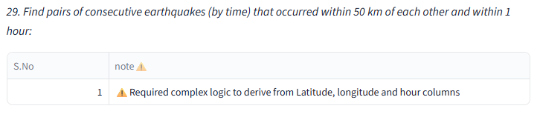
30. Determine the regions with the highest frequency of deep-focus earthquakes (depth > 300 km).
